Step-by-Step Guide to Downloading and Installing the GuardTrax Android Application
With the Android device, make sure the option“allowing installation from unknown sources”is turned on.

- Open the app drawer and go to Settings. (The Settings icon may be different on some phones.)
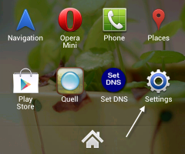

2. When you are in the Settings screen, scroll down to find the “Security”section and tap on it.
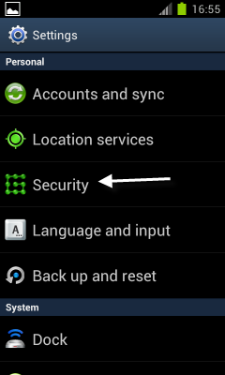

3. Scroll down to the “Device administration”section and check the “Unknown sources” option.
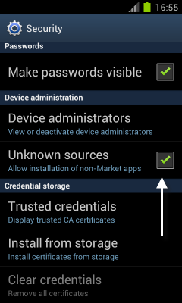

4. Tap OK when the warning window appears.
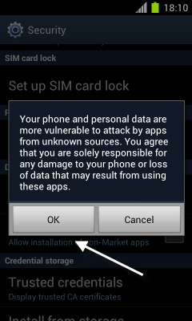

Whenyou have ensured 3rd party apps can be installed, on your Android…

- Go to www.guardtrax.com
- Click the “Services“ tab to enter the application download section
- Click the link Download GuardTrax Android Software

This should start the download process of the GuardTrax Android application…

To install the application:
- Go to your downloads on the Android device.
- Click the file that says GT.apk
- Verify and install the file.

Congratulations! You have successfully downloaded and installed the GuardTrax Android application.

